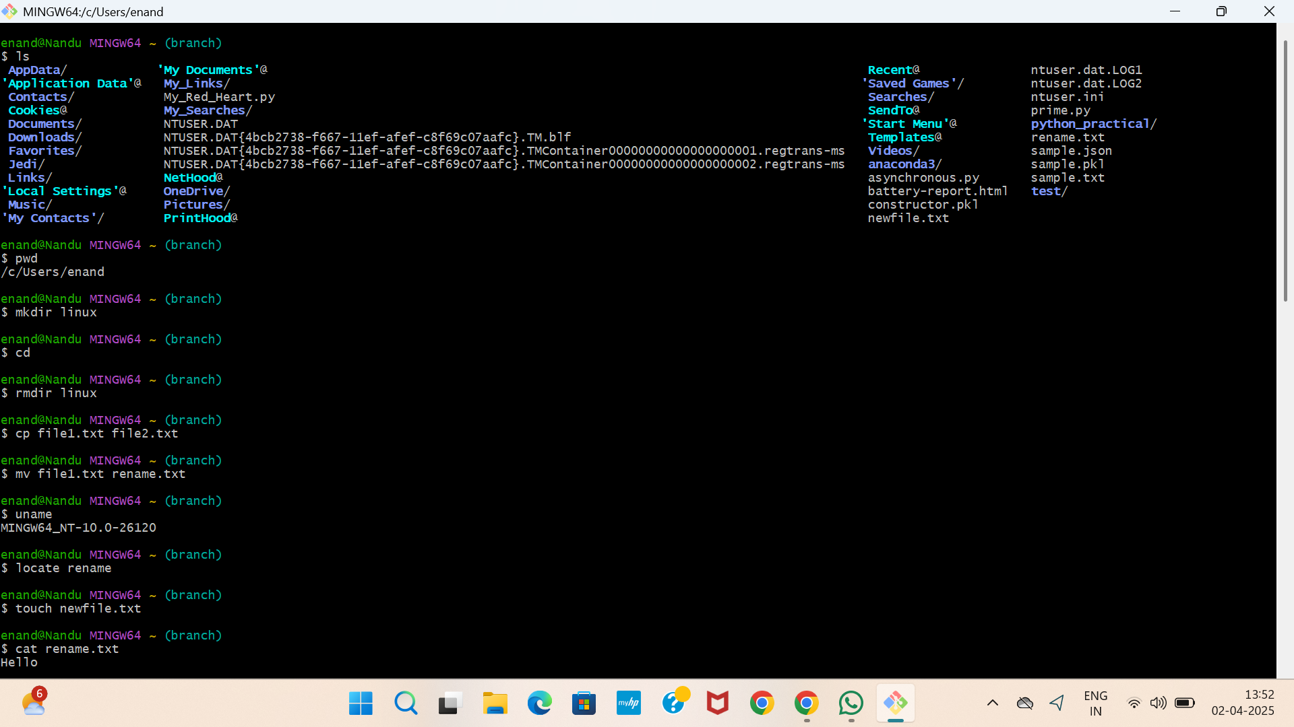

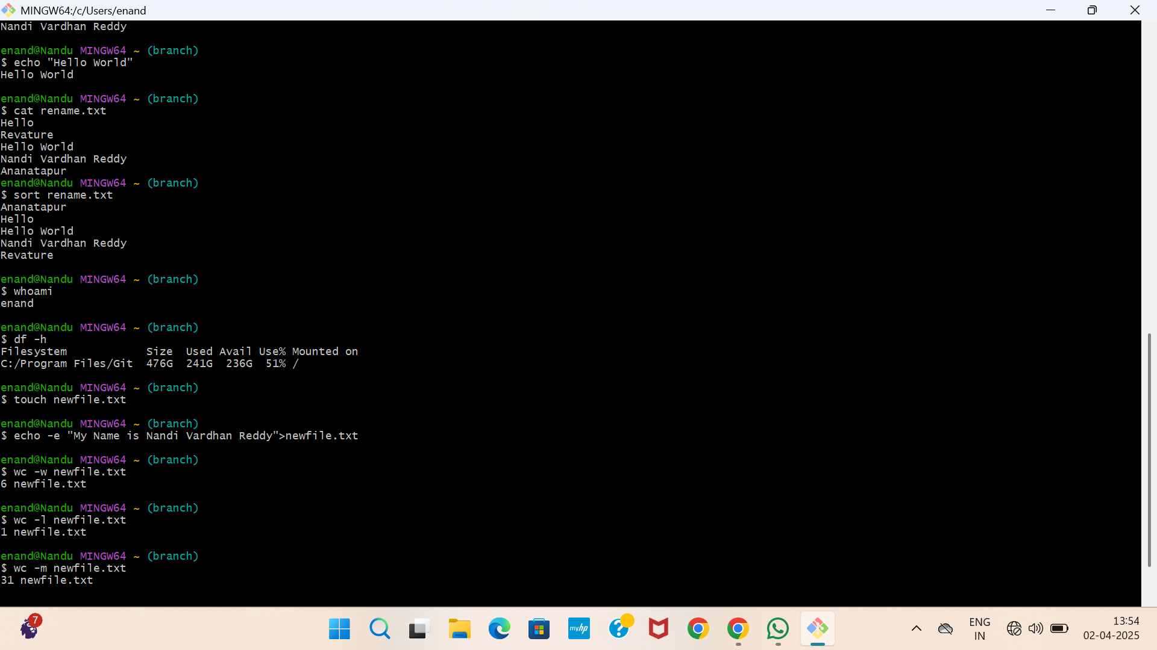

**I Perform Linux Commands in Git Bash to what the function they Can Perform :**

**1. Is command :** The [ls command](https://www.geeksforgeeks.org/practical-applications-ls-command-linux/) is commonly used to identify the files and directories in the working directory.

**2. pwd command :** The **[pwd command](https://www.geeksforgeeks.org/pwd-command-in-linux-with-examples/)** is mostly used to print the current working directory on your terminal.

**3. mkdir command :** This [mkdir command](https://www.geeksforgeeks.org/mkdir-command-in-linux-with-examples/) allows you to create fresh directories in the terminal itself.

**4. cd command :** The [**cd command**](https://www.geeksforgeeks.org/cd-command-in-linux-with-examples/) is used to navigate between directories. It requires either the full path or the directory name, depending on your current working directory.

**5. rmdir command in Linux :** The **[rmdir command](https://www.geeksforgeeks.org/rmdir-command-in-linux-with-examples/)** is used to delete permanently an empty directory.

**6. cp command in Linux :** The [**cp command**](https://www.geeksforgeeks.org/cp-command-linux-examples/)of Linux is equivalent to copy-paste and cut-paste in Windows.

**7. mv command :** The mv command is generally used for renaming the files in Linux.

**8. rm command :** [**rm command**](https://www.geeksforgeeks.org/rm-command-linux-examples/) in Linux is generally used to delete the files created in the directory.

**9. uname command :** The **[uname command](https://www.geeksforgeeks.org/uname-command-in-linux-with-examples/)** is used to check the complete OS information of the system.

**10. locate command :** The [locate command](https://www.geeksforgeeks.org/locate-command-in-linux-with-examples/) is generally used to locate the files in the database.

**11. touch command :** The [touch command](https://www.geeksforgeeks.org/touch-command-in-linux-with-examples/) creates an empty file when put in the terminal in this format as touch <file name>

**12. cat command :** The [cat command](https://www.geeksforgeeks.org/cat-command-in-linux-with-examples/) is the simplest command to use when you want to see the contents of a particular file.

**13. clear command :** The [clear command](https://www.geeksforgeeks.org/clear-command-in-linux-with-examples/) is a standard command to clear the terminal screen.

**14. grep command :** The [grep command](https://www.geeksforgeeks.org/grep-command-in-unixlinux/) is used to find a specific string in a series of outputs.

**15. echo command :** [echo command](https://www.geeksforgeeks.org/echo-command-in-linux-with-examples/) in Linux is specially used to print something in the terminal

**16. whoami command :**The **[whoami command](https://www.geeksforgeeks.org/whoami-command-linux-example/)** provides basic information that is extremely useful when working on multiple systems.

**17. sort command :** The **sort**command is used generally to sort the output of the file.

**18. df command :** [df command](https://www.geeksforgeeks.org/df-command-linux-examples/) in Linux gets the details of the file system.

**19. wc command :** [wc command](https://www.geeksforgeeks.org/wc-command-linux-examples/) in Linux indicates the number of words, characters, lines, etc using a set of options.

* wc -w shows the number of words
* wc -l shows the number of lines
* wc -m shows the number of characters present in a file